Subqueries:

Problem
Electricity_Reading(Nested Query)-Oracle

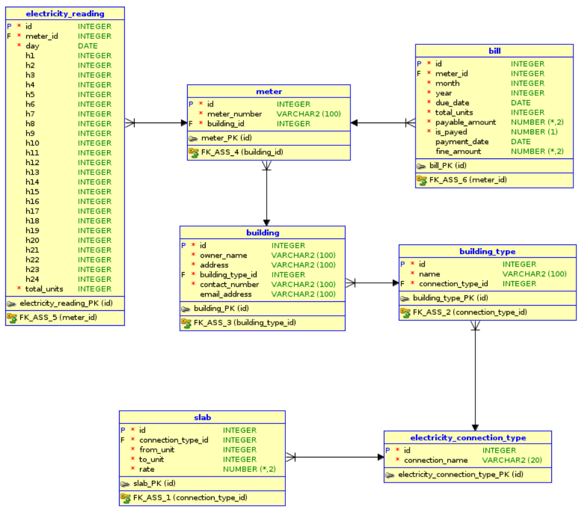

Q 1. Write a query to display all the building details in which building type is ‘Library’ .Display the records in ascending order based on their owner_name.
Ans :
SELECT b.id, b.owner_name, b.address, b.building_type_id, b.contact_number, b.email_address
FROM building b
JOIN building_type bt
ON b.building_type_id = bt.id
WHERE bt.name = 'Library'
ORDER BY b.owner_name;

Q 2. Write a query to display all the contact number of the building type 'Police Station' .Display the records in ascending order based on the contact number.
Ans :
SELECT b.contact_number
FROM building b
JOIN building_type bt
ON b.building_type_id = bt.id
WHERE bt.name = 'Police Station'
ORDER BY b.contact_number;

Q 3. Write a query to get the building type name of the given meter number 'SG824012'.
Ans :
SELECT bt.name
FROM meter m
JOIN building b
ON m.building_id = b.id
JOIN building_type bt
ON b.building_type_id = bt.id
WHERE meter_number = 'SG824012';

Q 4. Write a query to display the meter number of the building type 'College'.Display the records in ascending order based on their meter number.
Ans :
SELECT m.meter_number
FROM meter m
JOIN building b
ON m.building_id = b.id
JOIN building_type bt
ON b.building_type_id = bt.id
WHERE bt.name = 'College'
ORDER BY meter_number;

Q 5. Write a query to display the total units and payable amount of the particular meter number 'SG934826'.
Ans :
SELECT b.total_units, b.payable_amount
FROM bill b
JOIN meter m
ON b.meter_id = m.id
WHERE m.meter_number = 'SG934826';

Assess :

Problem
Metro_Station(Nested)-Oracle-iLearn

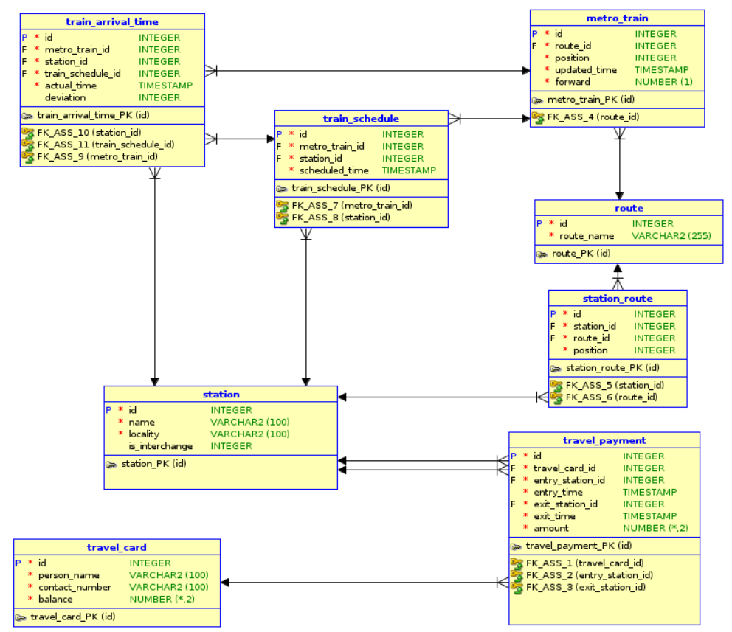
Q 1. Write a query to display the train details which belongs to the route 'North South line'.Display the records in ascending order based on position.
Ans :
SELECT mt.id, mt.route_id, mt.position, mt.updated_time, mt.forward
FROM metro_train mt
JOIN route r
ON mt.route_id = r.id
WHERE r.route_name = 'North South line'
ORDER BY mt.position;

Q 2. Write a query to display the person names whose entry or exit station is 'Marina Bay MRT Station' on '22-Dec-2017'.Display the records in ascending order based on person name.
Ans : SELECT person_name
FROM travel_card
WHERE id IN (SELECT travel_card_id
FROM travel_payment
WHERE entry_station_id IN (SELECT id
FROM station
WHERE name = 'Marina Bay MRT Station')
OR exit_station_id IN(SELECT id
FROM station
WHERE name = 'Marina Bay MRT Station'))
ORDER BY travel_card.person_name;

